Constructor
_______________________________________________________________
Q. What is constructor?
___________________________________________________________________________
Constructor is a function same name as class name but without return type called as constructor
Syntax of constructor
_________________________________________________________________________
class classname
{ classname() //constructor
{
}
}
Example:
class ABC{
ABC(){
}
}
Q. Why use constructor or what is benefit of constructor?
_________________________________________________________________________________
1. Initialize the class member at the time of object creation or object initialization purpose
______________________________________________________________________________

2. To call function at the time of object creation.
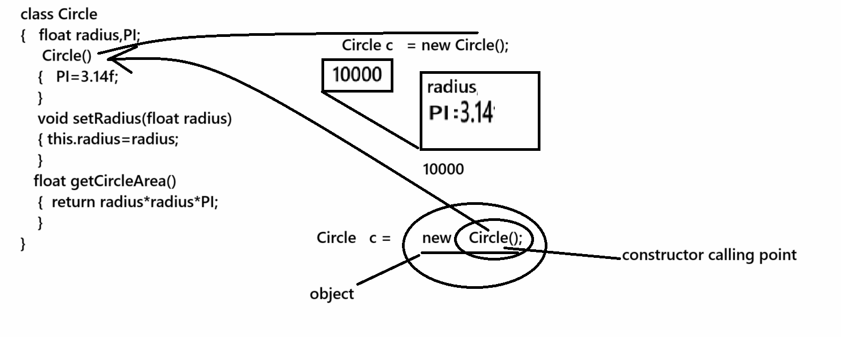
Note: if we declare not constructor within class then every class has one default constructor known as implicit constructor.
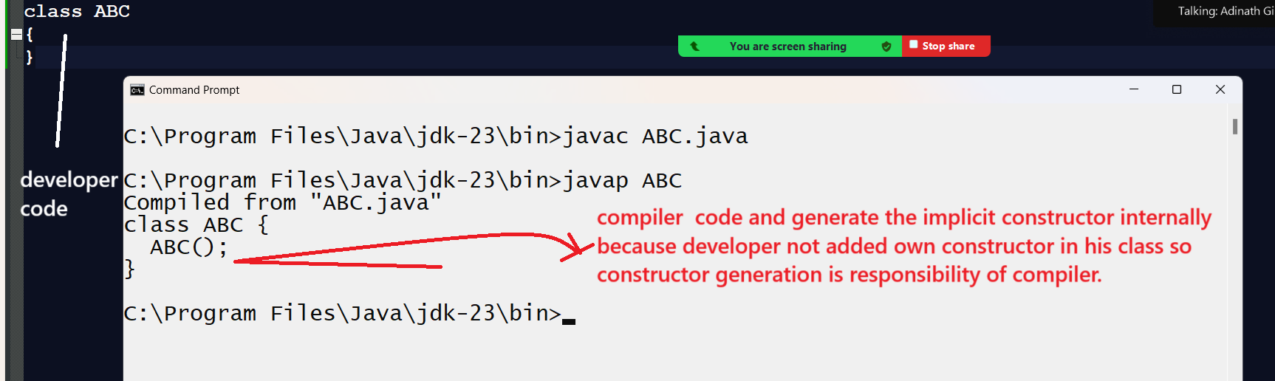
If we want to work with constructor we have some types of constructor
1. Default constructor: default constructor means user defined no argumented constructor called as
default constructor
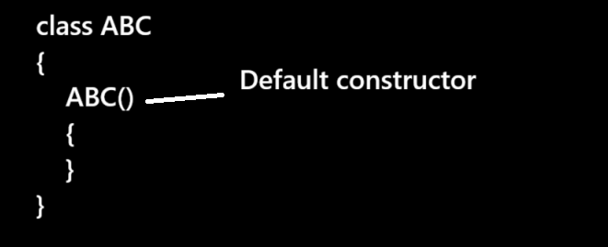
Note: Normally default constructor is choice of developer as per coding to initialize fix values at the time of object creation in instance variable or static variable
class Circle
{ float radius,PI;
Circle()
{
PI=3.14f;
}
void setRadius(float radius)
{ this.radius=radius;
}
float getArea(){
return radius*radius*PI;
}
}
public class CircleApp
{
public static void main(String x[])
{
Circle c = new Circle();
c.setRadius(3.0f);
float result=c.getArea();
System.out.printf("Area of circle is %f\n",result);
}
}
or
import java.util.*;
class Fibo
{
int f1,f2,fib;
Fibo(){
f1=0;
f2=1;
}
void printSeries(int limit){
System.out.printf("%d\n%d\n",f1,f2);
for(int i=1;i<=limit;i++)
{ fib=f1+f2;
f1=f2;
f2=fib;
System.out.printf("%d\n",fib);
}
}
}
public class FiboApp
{ public static void main(String x[])
{
Fibo f1 = new Fibo();
Scanner xyz = new Scanner(System.in);
System.out.println("Enter number");
int no=xyz.nextInt();
f1.printSeries(no);
}
}
2. parameterized constructor or argumented constructor
________________________________________________________________________________
When we pass parameter to constructor called as parameterized constructor.
Normally Parametarized constructor recommended by developer we want to initialize value to instance variable or class variable at the time of object creation but value vary every time or not fixed
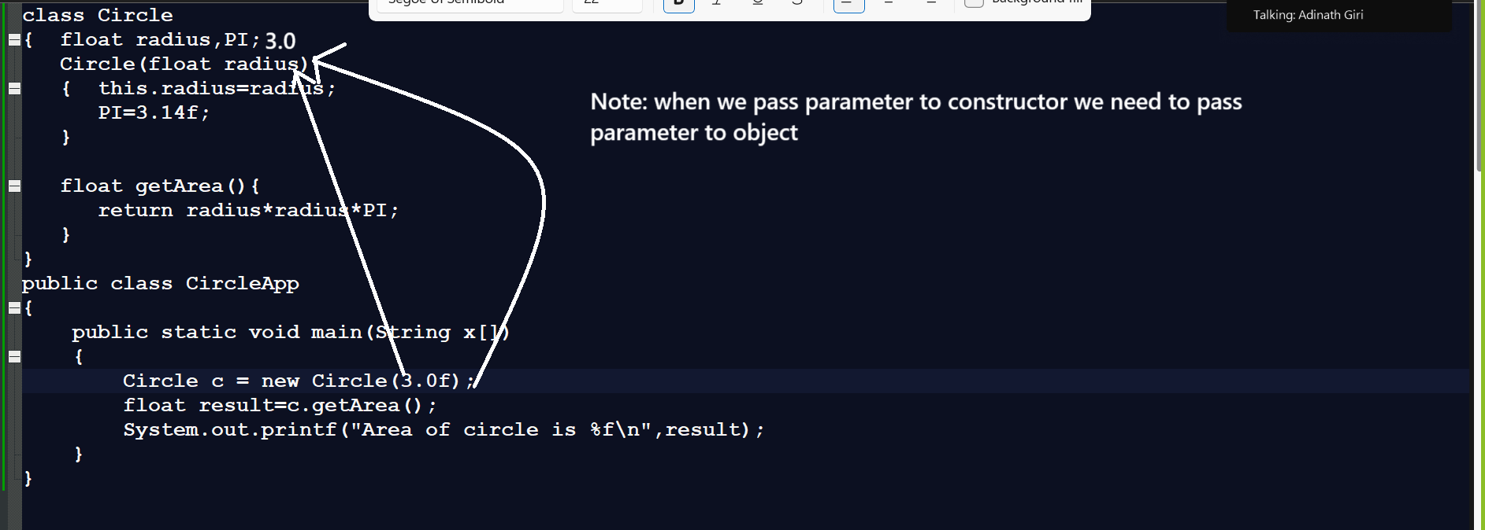
3. Overloaded constructor
4. this() constructor

